DATAFLOW DIAGRAMS

The figure below shows the dataflow for registration of voters. The voters personal info. is stored in smart contract after the transaction is successful.
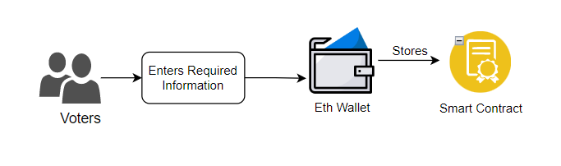

This figure presents the dataflow of voter’s login which consists of voters entering login credentials and confirming transaction, then the credentials are verified from smart contract and voter’s account is opened.
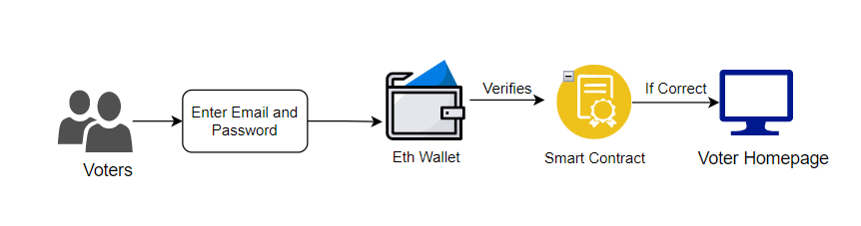

This dataflow diagram presents the admin’s login process which consists of admin entering login credentials and if it matches with the credentials from App.js it gives access to admin’s account.
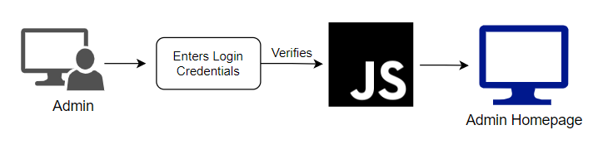

This dataflow diagram presents the flow of all the functions that can be performed by the admin which consists of add candidate, voter authentication, changing election phases, monitoring votes and publishing results.
All of the functions require transaction from wallet and the verification from the smart contract.
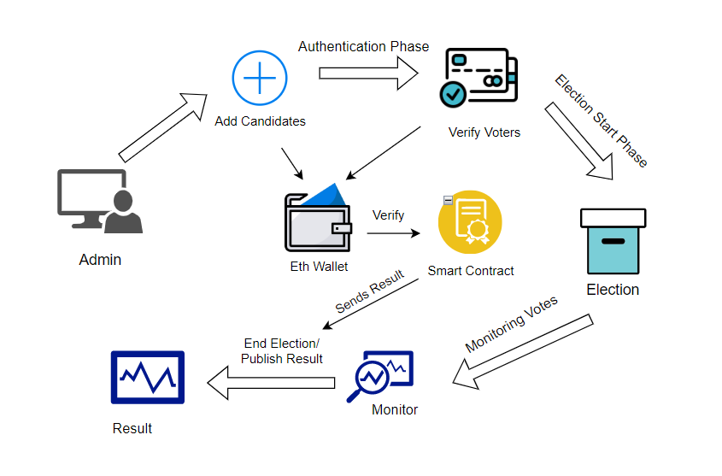
This dataflow presents the flow of all the functions that a voter can perform in this system which consists of voting the candidate and confirming the transaction and storing it to smart contract.
The stored votes are then published when the admin ends the election.
